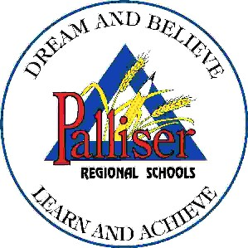
PALLISER REGIONAL SCHOOLS
FAMILY SCHOOL LIAISON PROGRAM
PARENTAL/STUDENT PERMISSION FOR INVOLVEMENT

I/We [name of parent(s)/guardian(s)/student], authorize, [student name] to receive services specified below through the Family School Liaison Program of Palliser Regional Schools until the end of the current school year or until this permission is rescinded, in writing:

Palliser Regional Schools provides a team of counselling professionals. As part of your child’s counselling service, we request permission for anonymous case consultations to occur among members of the professional team. Everything you say is confidential within the counselling team with the following exceptions:

- Principal and or designate
- If you give prior written permission to have it released.
- If there is a possibility of your child harming himself/herself or others, we are ethically bound to act in order to ensure safety.
- If the abuse of a child is involved, by law this must be reported.
- If we are subpoenaed by court to release the file.

Palliser Regional Schools participates in the Calgary-Rockvyview and Westview Student Health service plans, an integrated service delivery partnership. At the end of the school year, numerical data is collected and submitted to the Provincial Government as part of their reporting requirement.

Counselling services provided by the Family School Liaison Counsellor

parent/guardian’s signature date

Counselling services provided by the Family School Liaison Counsellor

student’s signature (16 and older) date

** Parameters of confidentiality reviewed and informed consent received as indicated by signature.

