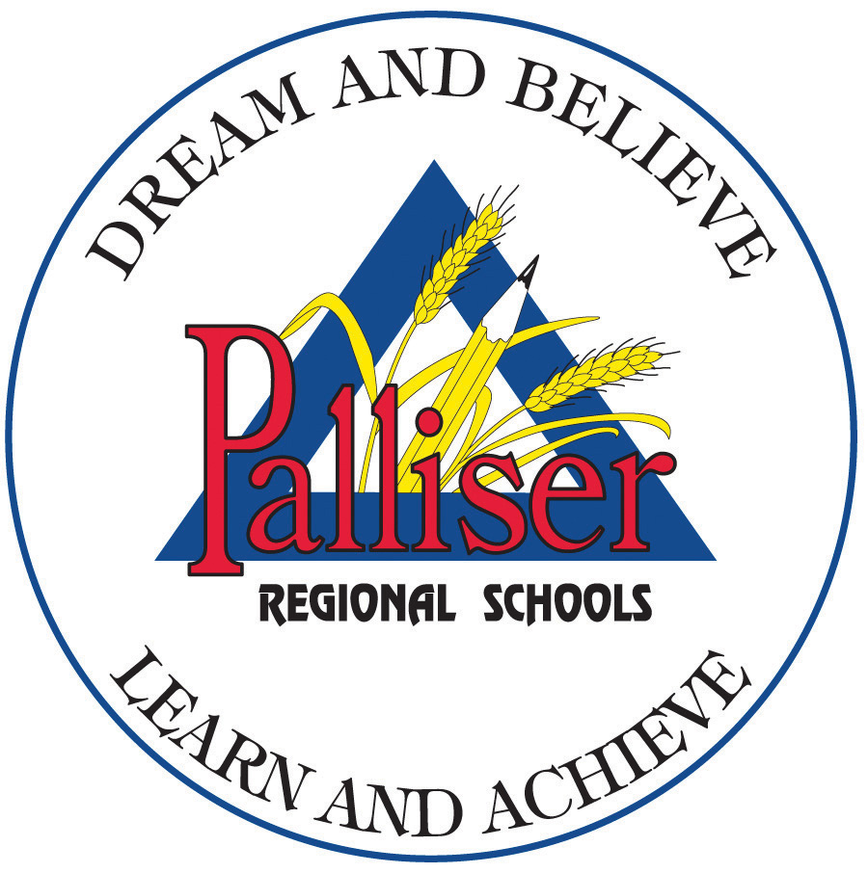
PALLISER REGIONAL SCHOOLS
HUMAN SEXUALITY INSTRUCTION
EXCLUSION REQUEST FORM
FOR STUDENTS

The Board offers instruction in Human Sexuality as part of its regular program of instruction, and each parent/guardian has the right to have their child(ren) excluded from the program. If you wish to have your child(ren) excluded, please complete the form below and return it to the school.

REQUEST FOR EXCLUSION

I am aware of the content and intent of the Human Sexuality Program to be taught in the school and wish to have my child(ren) excluded from the program.

_________________________________________ _________
Student's Name Grade

_________________________________________ _________
Student's Name Grade

_________________________________________ _________
Student's Name Grade

_________________________________________ __________________________
Parent/Guardian Signature Date

